26.40: a) Originally, 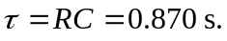The combined capacitance of the two identical capacitors in series is given by
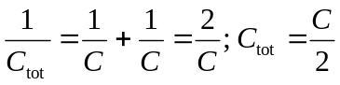
The new time constant is thus 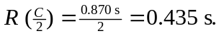
b) With the two capacitors in parallel the new total capacitane is simply 2 C. Thus the time constant is 